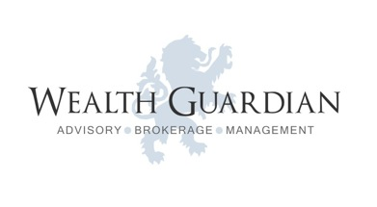 About Wealth Guardian Services Useful Information Contact us

***“Wealth Guardian is an Independent Asset Management Investment Firm that focuses on added value services to High Net Worth Individuals and Institutions.”***

*[](https://www.bing.com/images/search?view=detailV2&ccid=SIJF1cd3&id=8B27A3395532B7ECCFE3BFA53088FEE4E900B68D&thid=OIP.SIJF1cd3v8v4g01Y99tKGgEsC7&mediaurl=http://3.bp.blogspot.com/-aOVyyvDo6pY/TptUn-N7dqI/AAAAAAAAAjs/p9V-B3f_DCE/s1600/Lion%2Bwallpapers%2Bfor%2Bdesktop%2B2.jpg&exph=800&expw=1280&q=Lion+Desktop&simid=608051510015821839&selectedIndex=1)Like a lion guarding over its pride such is the core of our philosophy at W.G. Wealth Guardian, to provide guarded and bespoke investment related services that are truly independent and founded on sound judgment and objectivity.*

*Our offered service aims for prudent security and safety for your wealth, where quality and principles form the foundation of our professional conduct.*

*Professionalism, Objectivity, Competence, Diligence and Skillfulness are the qualities that drive our highly experienced Management Team. Our offered service is moulded by these qualities and stern regulations that represent and acts for the benefit of all clients, placing their interests and protection of wealth as top priority of the company’s offering.*

Regulated by the Cyprus Securities and Exchange Commission - License number: ----

**Risk Warning:** Trading in financial instruments may result in losses as well as profits. Past performance is no guarantee of future results. Trading in derivatives (e.g. options, futures, swap contracts) could result to the loss of the whole capital invested. Derivatives are bilateral contracts whose value depends upon the value of an underlying asset or index. Trading in leveraged financial instruments may result in losses greater than the initial invested capital. You should only invest in derivatives or leveraged financial instruments if you possess the necessary knowledge and experience to understand the risks involved, the investment meets your investment objectives and you are financially able to bear the investment risks.  For further information on risks inherent in investing, (link ‘click here’ of WG risk information)